**ReadMe Documentation of Project**

How to setup the project.

* Open the project in VsCode.
* Open a new terminal and go inside the frontend folder “cd frontend” and enter “npm install”
* After the node modules installed enter “npm start” to run the application.
* Application runs in <http://localhost:3000/>

GitHub Link:

* <https://github.com/Madush99/Practical-Project>

Page URLs:

* Login page: <http://localhost:3000/>
* Report page: <http://localhost:3000/report>
* Task Management Page: <http://localhost:3000/task>

Note: Can navigate to the following pages through the navbar.

Login

* Username : test
* Password: 123abc
* Validations added to the login form

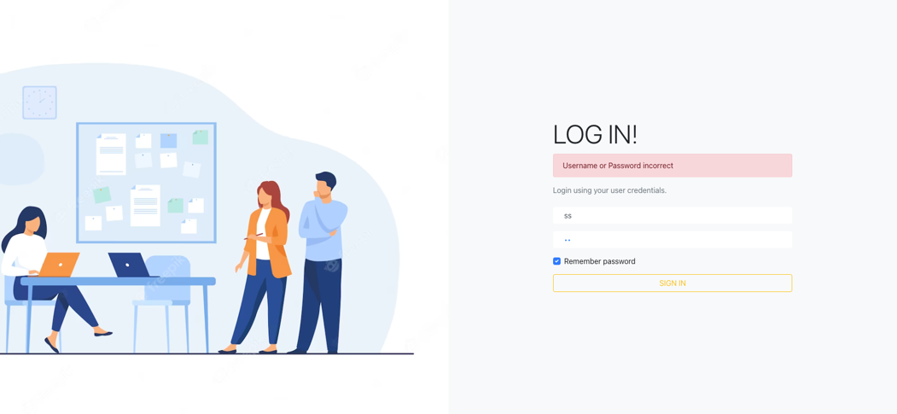

Logout

* Logout function is implemented to remove the saved user from the local storage.
* Logout is in the popup menu in the right side of the navbar.



Report Page

* In this page all the transactions and transaction summary are shown.
* Can view the full transaction details by clicking the “View transaction details” button relevant to the transaction in a popup dialog.

Task Management Page

* In this page it shows the Tasks added and number of tasks.
* By clicking on the “Add” button you can a task.
* After adding a task, task details will be shown in a card view.
* In the card view there are buttons to delete, update and change the status of the task.

UIs

* Task management page:

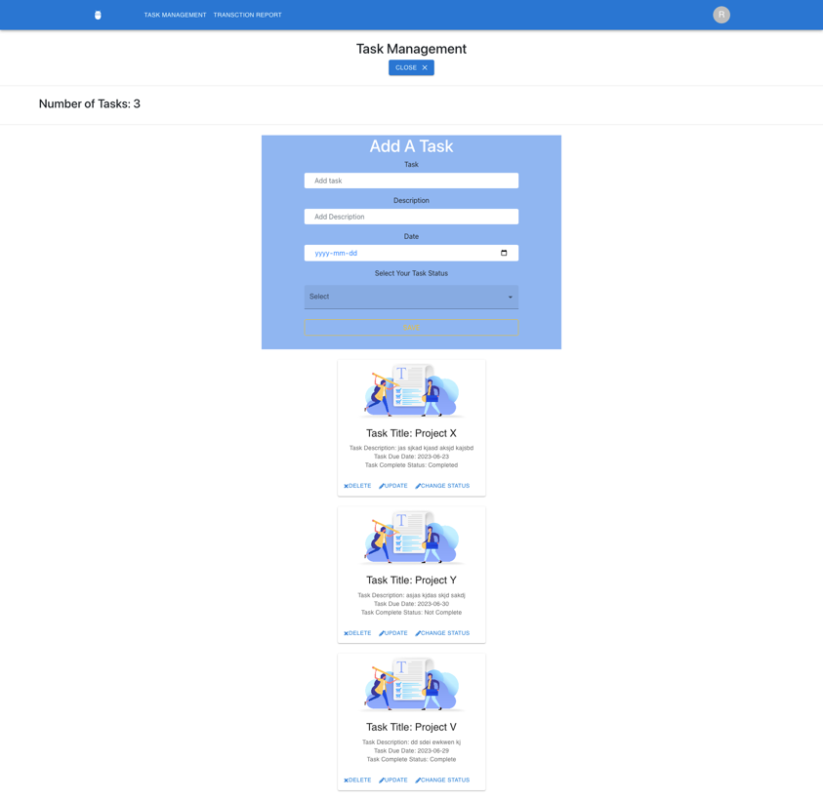

* Report Page:

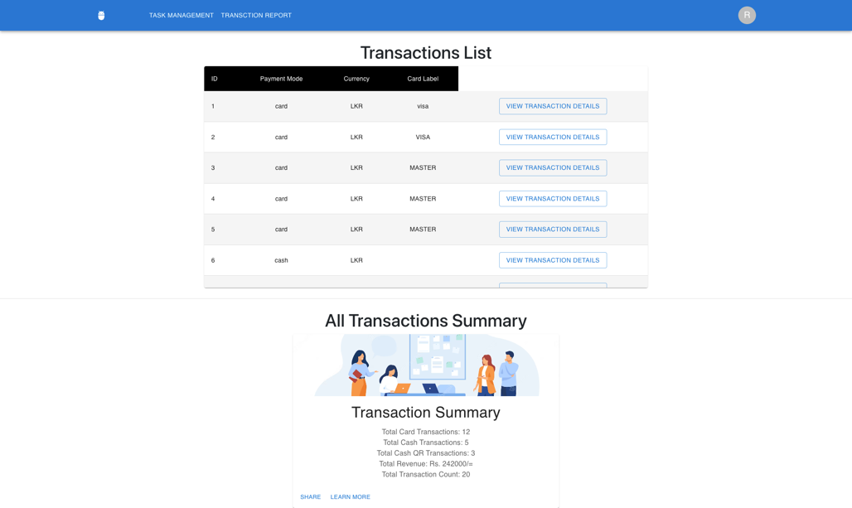

* Login Page:

